General Code Group Listing
This page renders a read-only view of all general code groups that exist in the system. A query facility, which allows the user to create specialized selection criteria to filter the results, does not exist. Its functionality includes adding a group, editing an existing group, deleting a group, and viewing the general codes related to a selected group.

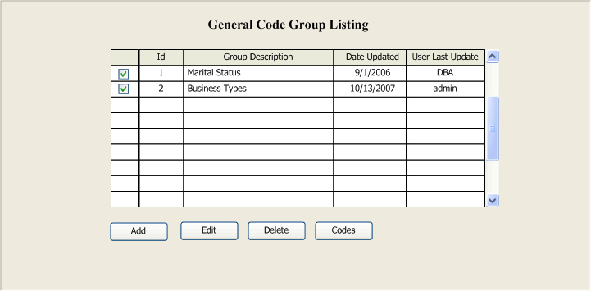

Add Button – Invokes a blank General Code Group Edit screen allowing the user to add a new group. No selections are required, and this process will ignore any selections that may exist. When the user is returned to the list page, the results should be refreshed including the new group added.

Edit Button – Invokes the General Code Group Edit screen populated with input controls containing data pertaining to the selected group. Only one selection is required. An error message should be displayed when zero or multiple selections are discovered for this action. When the user is returned to the list page, the results should be refreshed with the most recent changes made to the previously selected group.

Delete Button – Deletes a General Code Group from the list. This action requires one or more groups to be selected. If this fails to be true, display an error message as in-process or out-of-process. A message should be displayed at the bottom of the page indicating the outcome of the operation. If any of the selected groups are linked to other data entities as a foreign key, skip processing the group in violation and display a message at the bottom of the screen detailing that the operation finished successful with warnings. The warnings should represent the group that attempted to violate the foreign key rule. Note: This issue is not an error or an exception but informational, and the process should not be interrupted in such cases.

Codes Button – This action will invoke the General Codes List page for the selected group. It is required that one group be selected for this operation. An error message should be displayed for zero or multiple selections.

General Code Group Edit
This page renders the input control necessary for adding or modifying a General Code Group item. It is required that the caller passes the general code group id that is to be edited. When adding a group, the id should equal zero. When editing a group the id should be greater than or equal to one. Otherwise, an error must be noted.

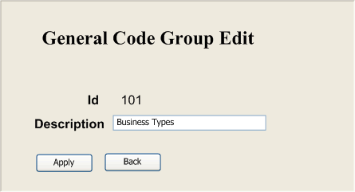

Apply Button – This action will apply the changes made on this page to the database. Any errors occurring during this action should be captured and handled by this page. The description field is required and cannot be blank or null. Validations for the description field can be implemented on the client or server.

Back Button – Returns the user back to the General Code Group List page. A Cancel action can be performed by clicking the Back button before applying the changes to the database.

General Code List
This page presents a read-only view of general codes filtered by a general code group item. Its functionality includes adding a code item, editing an existing code item, and deleting a code item. It is a requirement that the caller of this page sends a general code group id to be used as the selection criteria for gathering all related codes.

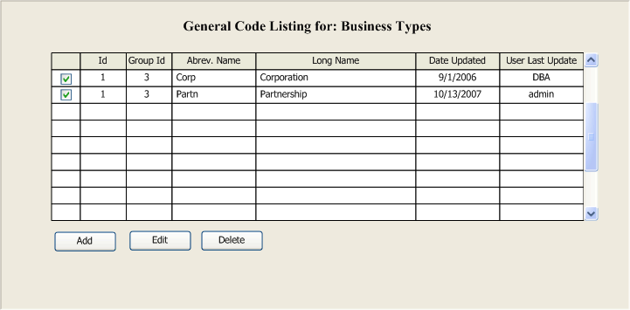

Add Button – Invokes a blank General Code Edit screen allowing the user to add a new code item for a particular code group. No selections are required, and this process will ignore any selections that may exist. When the user is returned to the list page, the results should be refreshed including the new code item added.

Edit Button – Invokes the General Code Edit screen containing input controls populated with data pertaining to the selected code item. Only one selection is required. An error message should be displayed when zero or multiple selections are discovered for this action. When the user is returned to the list page, the results should be refreshed with the most recent changes made to the previously selected code item.

Delete Button – Deletes a General Code item from the list. This action requires one or more code items to be selected. If this fails to be true, display an error message as in-process or out-of-process. A message should be displayed at the bottom of the page indicating the outcome of the operation. If any of the selected code items are linked to other data entities as a foreign key, skip processing the group in violation and display a message at the bottom of the screen detailing that the operation finished successful with warnings. The warnings should represent the code item that attempted to violate the foreign key rule. Note: This issue is not an error or an exception but informational, and the process should not be interrupted in such cases.

General Code Edit
This page renders the input controls necessary for adding or modifying a General Code item. It is required that the caller passes the general code item id and the group id that is to be edited. When adding a code item, the id should equal zero. When editing a code item the id should be greater than or equal to one. Otherwise, an error must be noted.

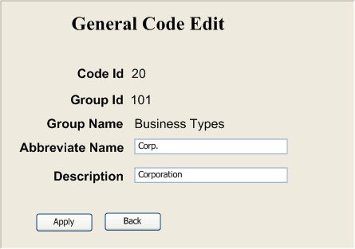

Apply Button – This action will apply the changes made on this page to the database. Any errors occurring during this action should be captured and handled by this page. The field, Abbreviated Name, is optional. The description field is required and cannot be blank or null. Field validations can be implemented on the client or server.

Back Button – Returns the user back to the General Code List page. A Cancel action can be performed by clicking the Back button before applying the changes to the database.

